List of Tables:

- Table 1: Software Requirements
Requirement | Description
Java Development Kit (JDK) | Version 8 or above
Apache Net beans (IDE) | Version 10 LTS or above

- Table 2: Hardware Requirements
Requirement | Description
Computer System | Minimum 4GB RAM, Dual-core Processor
Internet Connection | Stable , minimum 5 Mbps

List of Figures:
- Figure 1: Use Case Diagram
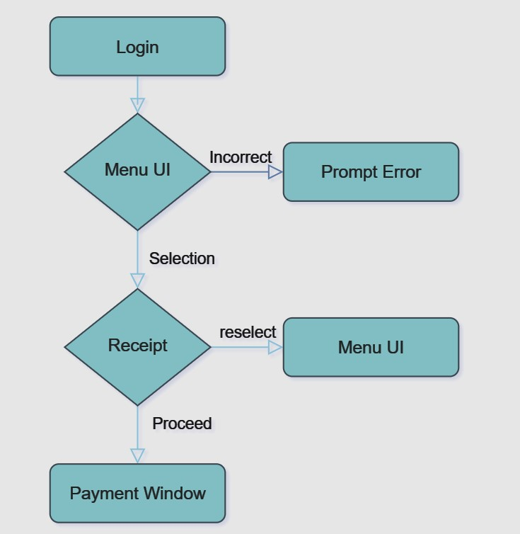

Description: Represents the various interactions between users and the system including registration, login, menu browsing, order placement, and payment

Abbreviations:
- UI: User Interface
- DB: Database

- INTRODUCTION

1.1 Motivation:
The motivation behind developing an online food ordering system stems from the increasing reliance on digital platforms for everyday tasks. This system aims to bridge the gap between consumers and owners of the canteen, providing a seamless, efficient and hassle-free experience for students and staff.

1.2 Problem statement:
Traditional methods of food ordering often involve phone calls, long wait times, and limited menu visibility. This project addresses these inefficiencies by offering an online platform where users can browse menus, place orders, and make payments effortlessly.

1.3 Project Objectives:
- Designing an intuitive and user-friendly interface for easy navigation.
- Implementing functionalities for order management and processing.
- Ensuring data security and privacy through credential DB.
- Providing feedback options to enhance user satisfaction.

1.4 Project Report Organization:
This report is organized into several sections, each focusing on a specific aspect of the project. It begins with an introduction to the project goals and objectives, followed by a literature review, requirement analysis, system design, implementation details, conclusion, and references.

- LITERATURE REVIEW

2.1 Existing work:
A review of existing online food ordering systems reveals various approaches to user interface design, order management, and payment processing. Some systems excel in user experience but lack user satisfaction, while others prioritize security but compromise on usability. Understanding the strengths and weaknesses of these systems will guide the development of our solution.

2.2 Limitations of existing work:
Common limitations observed in existing systems include:
- Complex user interfaces leading to user dissatisfaction.
- Lack of feedback options leading to gap between the consumers and the canteen owners.
- Lack of personalized recommendations resulting in reduced user engagement.

- REQUIREMENT ANALYSIS

3.1 Software requirements:
The software requirements for the online food ordering system include:
- Java Development Kit (JDK) for application development.
- Email service provider (e.g. Gmail) for feedback portal.
- Apache NetBeans IDE for quick UI design.
These software components form the foundation of the system and ensure compatibility and reliability.
3.2 Hardware requirements:
- Computer system with a minimum of 4GB RAM and a dual-core processor to support the Java application.
- Stable internet connection with a minimum speed of 5 Mbps to ensure uninterrupted access to the online platform.
These hardware specifications are essential for optimal system performance and user experience.
3.3 User Requirements:
The user requirements for the online food ordering system encompass various features and functionalities that cater to the needs of different user groups. These requirements include:
- User registration and login functionality to access personalized services.
- Intuitive options for browsing restaurants and menus based on preferences.
- Secure payment gateways to facilitate seamless transactions and build trust among users.

Meeting these user requirements is crucial for enhancing user satisfaction and retention.

- SYSTEM DESIGN
4.0 Proposed System Architecture:
The online food ordering system is a standalone desktop application developed using Java Swing. While the application primarily operates on the client-side, it interacts with an online database to access canteen inventory information. The architecture of the system remains a client-server model, where the client-side application communicates with the online database server to retrieve inventory data. The application logic and user interface components are encapsulated within the standalone application.
4.1 Proposed Methods/Algorithms:
To enhance the user experience and optimize system performance, the following methods and algorithms will be implemented:
- User authentication using credential coordinating to ensure the security of user credentials.
- Menu recommendation system based on user preferences through constant feedback, to personalize the browsing experience and increase user engagement.
These methods and algorithms leverage data analytics to deliver customized recommendations and improve overall system efficiency.
4.2 Class / Use Case / Activity / Sequence Diagrams:

4.3 Datasets and Technology Stack:
Datasets: The system will utilize an online database to store canteen inventory information, including menu items, pricing, stock levels, and order details. Additionally, sample datasets may be used for testing and development purposes.
Technology Stack:
- Frontend: Java Swing for developing the desktop application user interface.
- Backend: Java for application logic and database connectivity.
- Networking: Data cloud services for communication between the client-side application and updating the source code as required , simultaneously deploying the new database to the app.

